CprE 1850 – Lab #1

Maxwell Miller

1.1: MITS Altair 8800
Min RAM: 0.256K; 256 bytes; or 2048 bits
Max RAM: 64K; 64,000 bytes; 512,000 bits
CPU: Intel 8080 (2.0 MHz)
1.2: MOS KIM-1
RAM: 1.024K; 1024 bytes; or 8192 bits
CPU: MOS 6502 (1.0 MHz)
1.3: Apple 1
Min RAM: 4K; 4,000 bytes; or 32,000 bits
Max RAM: 64K; 64,000 bytes; 512,000 bits
CPU: MOS 6502 (1.0 MHz)
1.4: IBM Personal Computer (PC) 5150
Min RAM: 16K; 16,000 bytes; or 128,000 bits
Max RAM: 256K; 256,000 bytes; 2,048,000 bits
CPU: Intel 8088 (4.77 MHz)
1.5: Apple Macintosh
Min RAM: 128K; 128,000 bytes; or 1,024,000 bits
Max RAM: 512K; 512,000 bytes; 4,096,000 bits
CPU: Motorola 68000 (7.83 MHz)

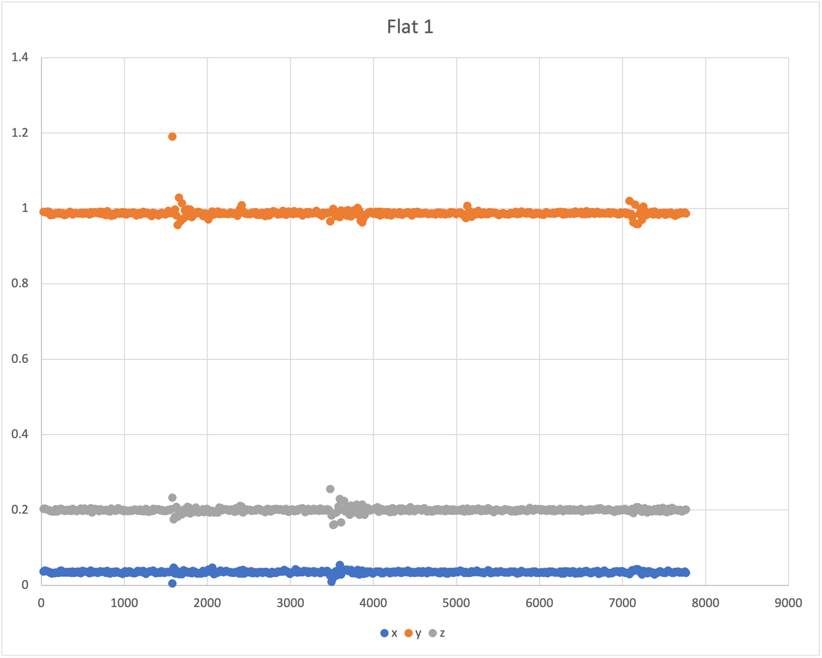
Unclear on why there’s $\sim 0.2g$ on the z-axis
Unclear on why there’s $\sim 0.2g$ on the z-axis
Essentially zero g being applied in the x axis
Almost 1g being applied straight down

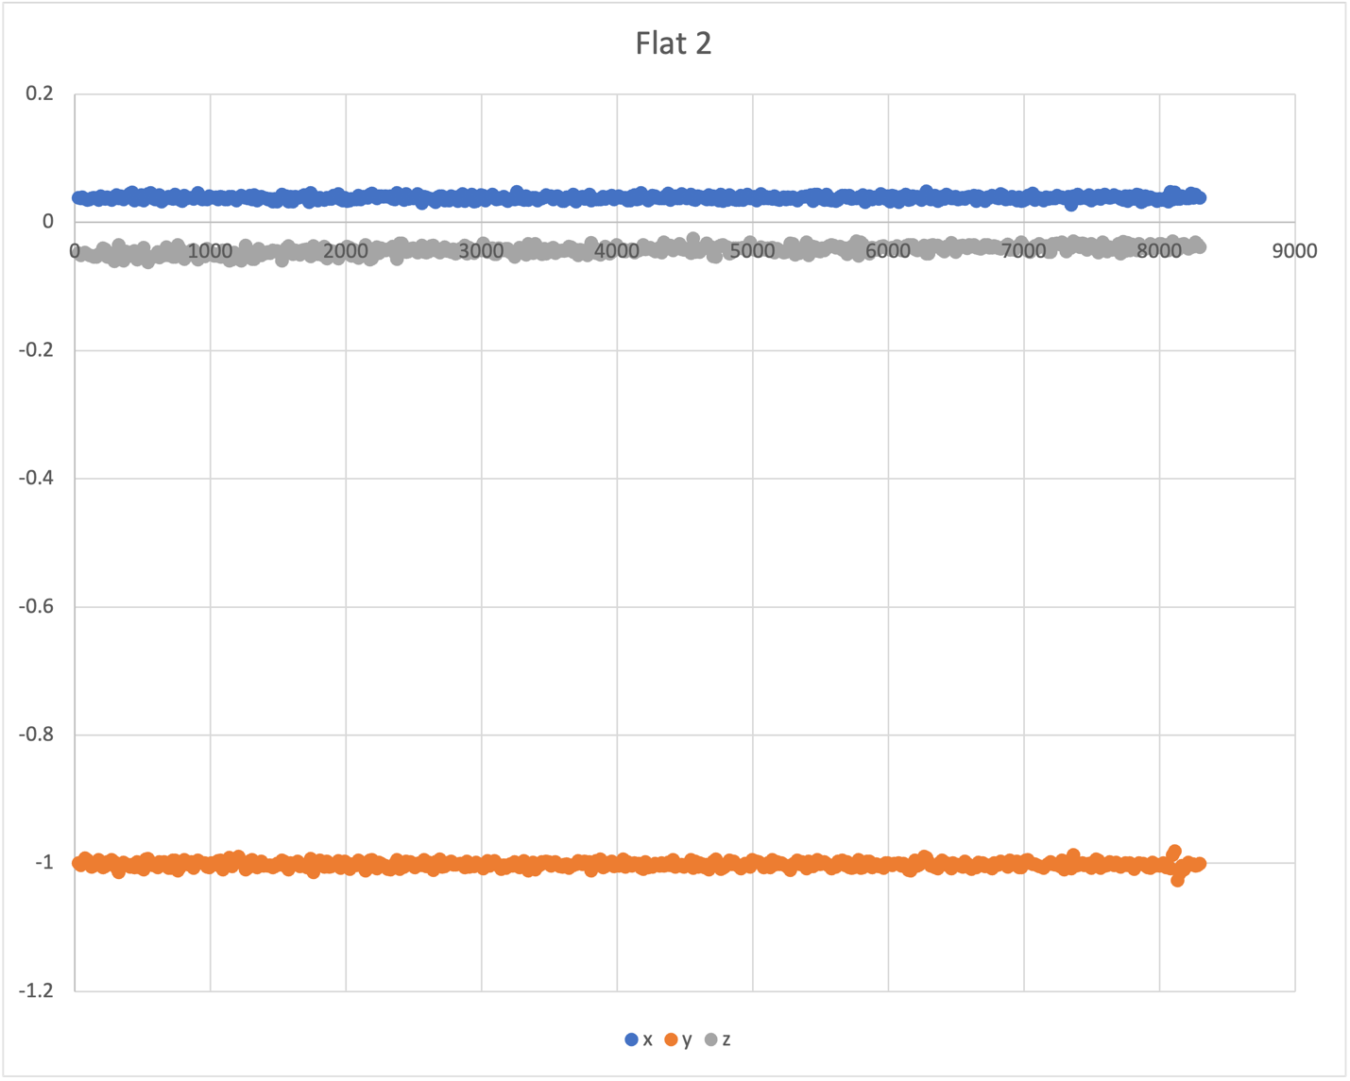
Essentially zero g being applied in the x&z axis
Almost exactly 1g being applied

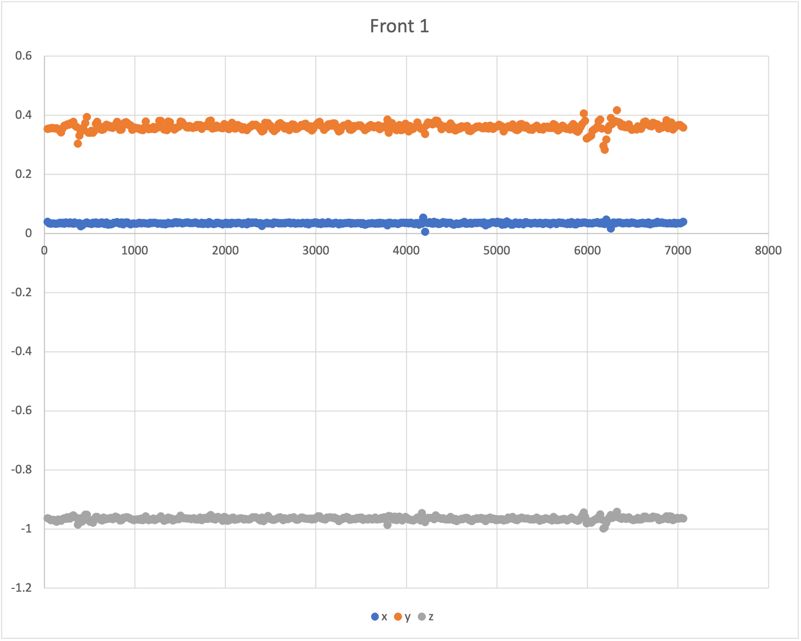
Basically, no g-acceleration in this direction
We are experiencing a little bit of g-acceleration in this direction as well
Almost 1g

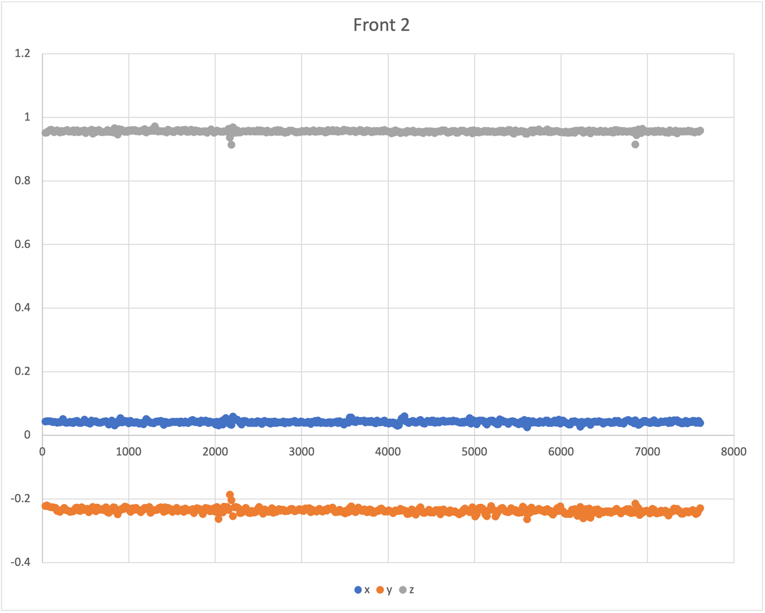
The accelerometer doesn’t seem to care about directionality, just abs value, since this value should (in theory) be identical to the other one
We are experiencing a little bit of g-acceleration in this direction as well
Basically no g-acceleration in this direction

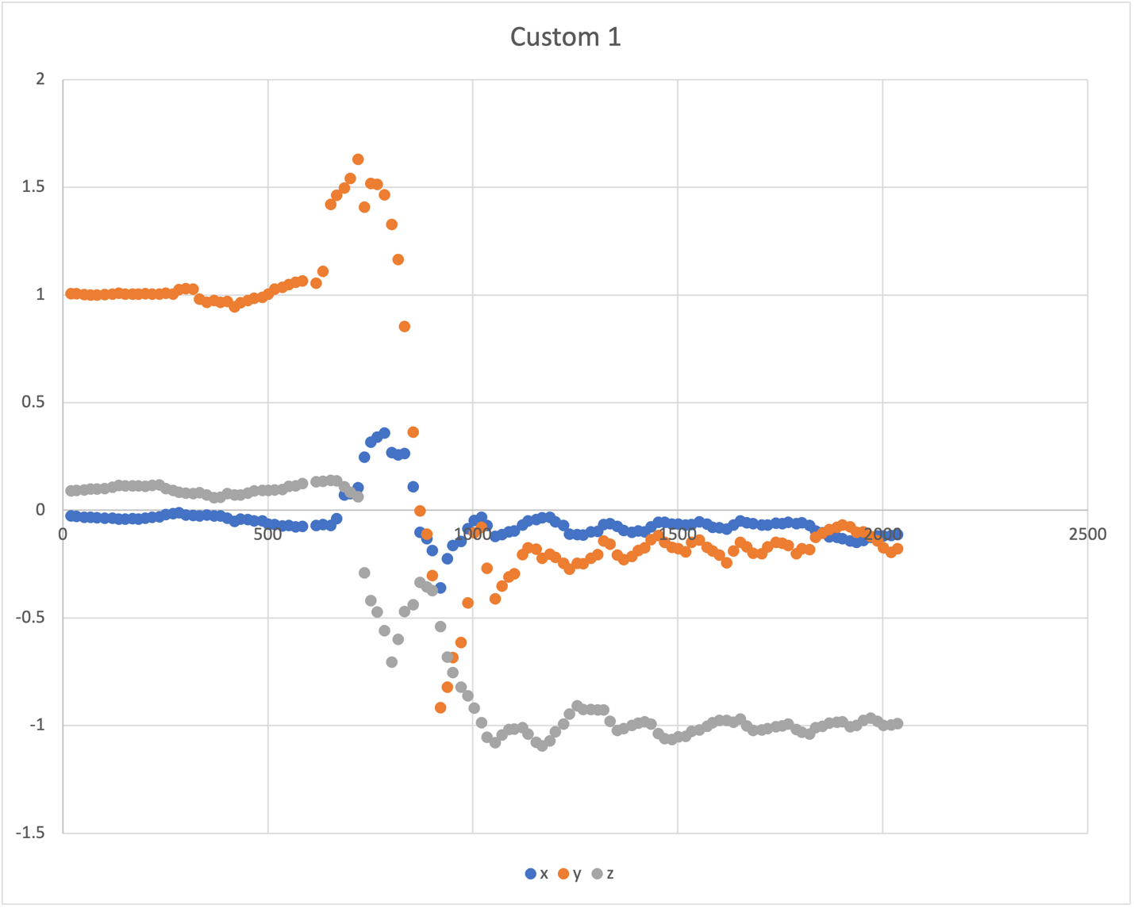
Xy follow a sin pattern and then return to zero, z holds at -1g
Spike In all 3 directions, but mostly in y

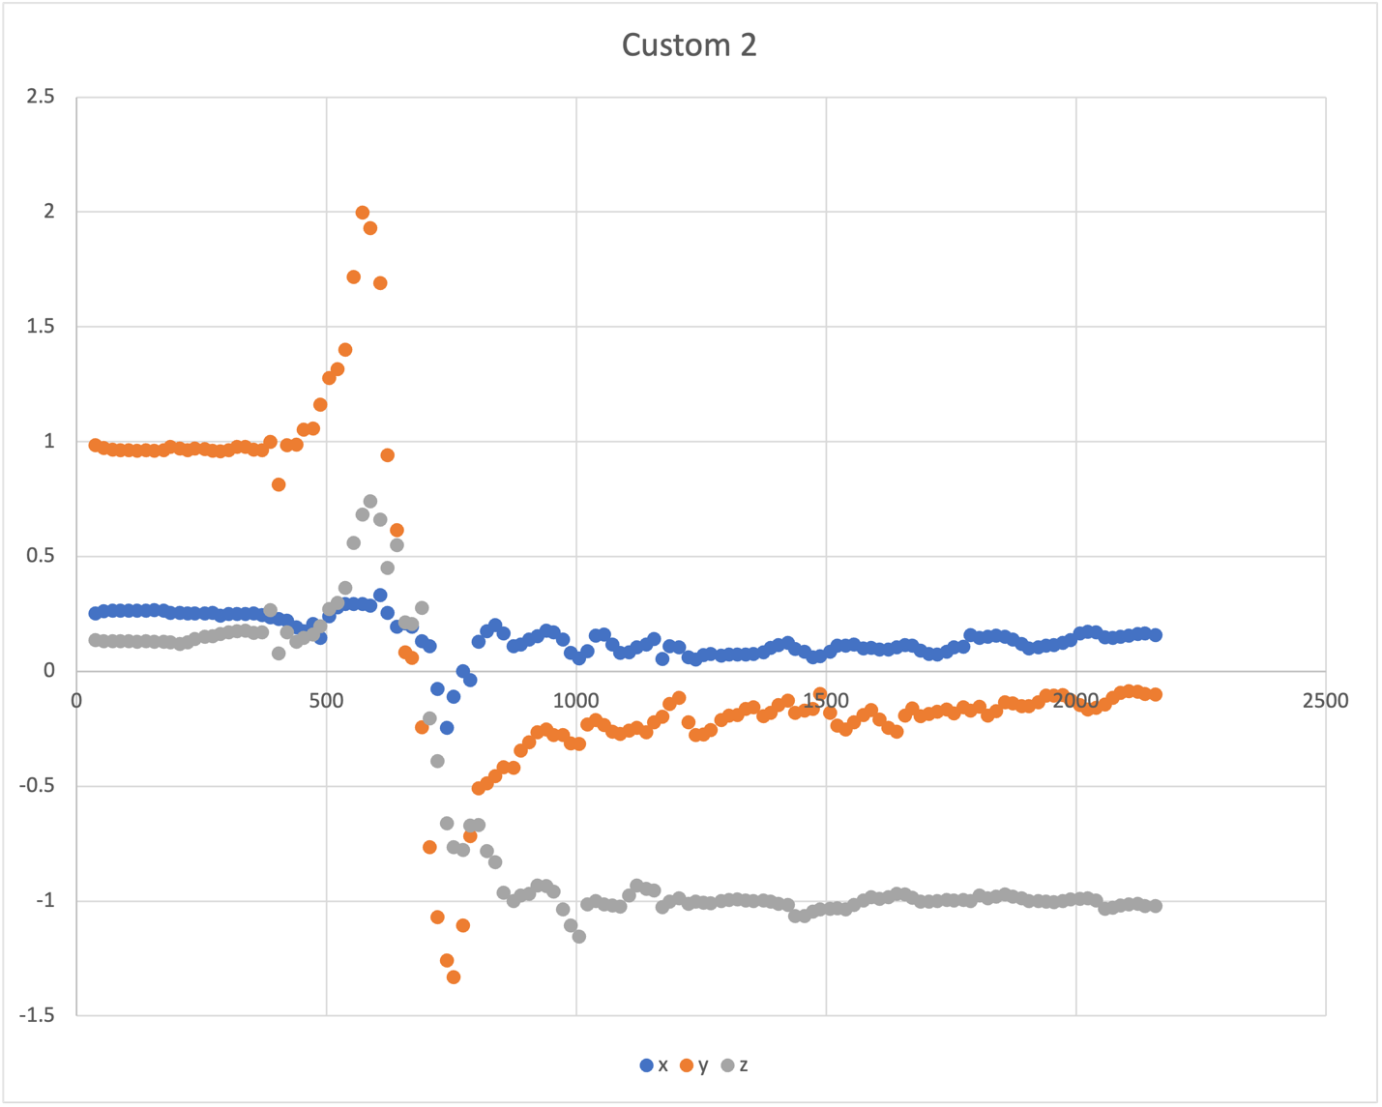
Xy follow a sin pattern and then return to zero, z holds at -1g
Spike In all 3 directions, but mostly in y

Graph Questions
- I believe that each column is the relative gravitational acceleration excreted on the controller.
- Most likely “-t” is to record pan/tilt/roll acceleration and “-g” makes it relative to the gravitational content of $g=9.8m/{s^{2}}$, so when the data is 1, it means the applied acceleration is $g$.
- It is measuring in g-acceleration, or relative gravitational acceleration.
- See graphs above.

Joystick Calibration
- What are you vertical and horizontal joystick equations? Are they similar or not? Why or why not?
  - Both were: $f(x)=\frac{x}{128}$. It’s likely that both directions use the same sensor, resulting in the same 8-bit (1-byte) readout in both directions, resulting in the -128 to 127 range, having the first bit determine if the number is positive or negative, and the following bits representing $2^{0}$ through $2^{6}$
- What did you find as the center point? Explain why it is or is not 0?
  - It’s not zero (as I explained above in 4.1), it’s between 0 and 1. Practically this resulted in the sensor sometimes reading out as 0 and sometimes as 1.
- What could cause the center to not be 0?
  - See 4.1 and 4.2
- What could you change to make the center be 0?
  - It’s never going to be perfectly zero due to physical limitations, along with the way binary works.

